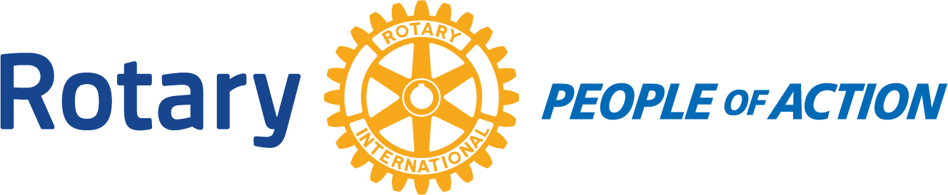

Winslow Rotary Club # 1242 August 5, 2020
Call to order: 12:12pm by President Kevin Coolidge
Pledge of Allegiance
Prayer given by: Harold Soehner
Announcements:
Bob Hall-Chamber of Commerce: The Annual Christmas Parade was officially canceled. The Chamber will not promote anything state wide and no vendors. But there is a community parade planned that will be on the same day (weekend before Thanksgiving) and will zig zag around town. Bob is hoping that Rotary will still participate.
Meeting:
Kristy presented an abbreviated treasures report. *see attached
Jessica read the Board Meeting minutes.
Kevin passed out business cards with the 4 Way Test on one side and meeting dates and times on the other. This is due to the discussion from the Board Meeting. He then read the history of the 4 Way Test. Kevin also talked about Dues=what all it pays for. $20.50: $13 dues & $7.50 extra to help pay for projects (General Fun) *What to do with past due accounts was discussed. If after 45 days in the rears the President will call the member and discuss a plan.
Going forward when a new member joins the club there will be an induction ceremony to make the day more memorable.
Each club officer was handed a packet with their duties. Kevin asked each officer to review.
The Board did a quick vote to approve the purchase of 3 popups for the food distributing.
A reminder email will go out the food distribution the day before. This next distribution we will possibly be short on help.

Adjournment: 12:56 pm
Date/Time of Next Meeting: August 12, 2020
Respectfully Submitted By: Jessica Cox-Atha, Club Secretary

