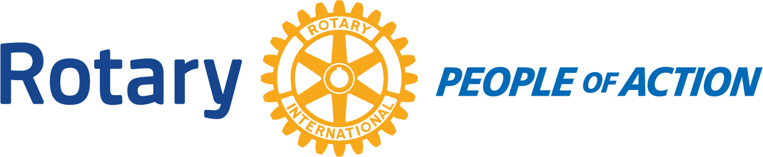

Winslow Rotary Club # 1242 August 12 2020
Call to order: 12:13pm by President Kevin Coolidge
Pledge of Allegiance
Prayer given by: David Hartman
Announcements:
WUSD has pushed back in person classes until October 12, 2020.
Kevin received his Paul Harris Fellow for his donations to the RI Foundation.
The next food distribution will be August 27th. We will be short on volunteers so please get the word out.
Meeting: Program: Kevin Coolidge
Read an essay about living the 4 Way Test.
Adjournment: 12:57pm
Date/Time of Next Meeting: August 19, 2020
Respectfully Submitted By: Jessica Cox-Atha, Club Secretary

