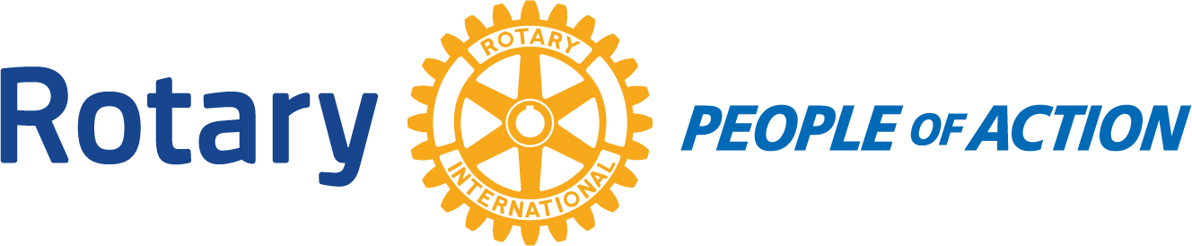

BOARD MEETING
Winslow Rotary Club # 1242 September 23, 2020

Call to order: 12:16pm by President Kevin Coolidge

Pledge of Allegiance

Prayer given by: Greg Hackler

Board Members Present:
Kevin Coolidge Kristy Armijo Jessica Cox-Atha
Jimmy Atha Chipper Cunningham Greg Hackler
Board Members Absent:
Rotarians Present at meeting:
Stephanie Lugo---Guest/Mike Shumway

4 Way Test

Items discussed:
*Kevin; The district has refunded the Club $10 per member due to Covid-19. It was decided the $380 we have received so far will go into our Scholarship Fund.
Rotary is starting a Polio Challenge.
*Chipper; The first Backpack Program food delivery will be October 12. So far there are 37 kids signed up.
Discussed how the mobile pantry is running and the issues that we are having.

Adjournment: 12:53pm

Date/Time of Next Meeting: October 7, 2020

Respectfully Submitted By:
Jessica Cox-Atha, Club Secretary

