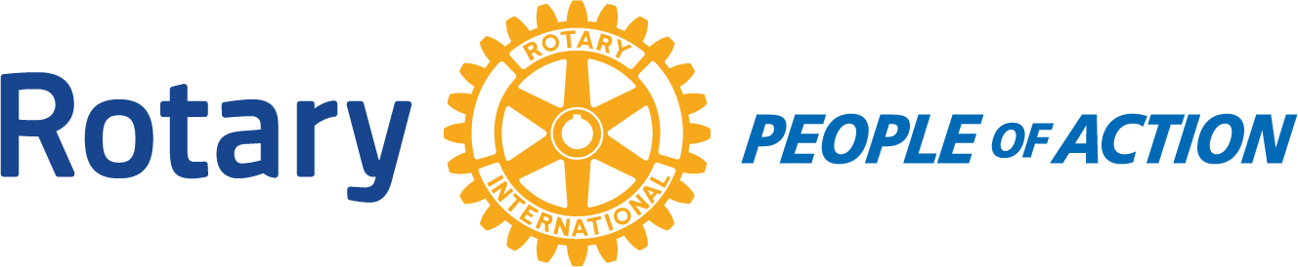

BOARD MEETING
Winslow Rotary Club # 1242 August 26, 2020

Call to order: 12:13pm by President Kevin Coolidge

Pledge of Allegiance

Prayer given by: Greg Hackler

Board Members Present:
Kevin Coolidge Kristy Armijo Jessica Cox-Atha
Jimmy Atha Chipper Cunningham Greg Hackler
Board Members Absent:
Rotarians Present at meeting:
Harold Soehner Elias Jouen Stephanie Lugo
Bob Hall

4 Way Test

Announcements:
Elias announced that the City has approved Ken Arens to be Chief of Police.

Items discussed:
*Order new Club banner. Bob Hall donated $250 to pay for banner.
*Kevin bought a 4 Way Test banner
*Discussion about increasing dues so more money can be sent to the Foundation. A new line item will appear on the monthly dues invoice.
*Chipper will talk to Frank about Venmo.
*Greg as Membership Chair talked about how the new member application submission will go.

Adjournment: 12:49pm

Date/Time of Next Meeting: September 2, 2020

Respectfully Submitted By:
Jessica Cox-Atha, Club Secretary

