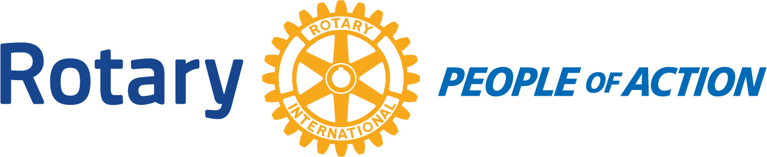

Winslow Rotary Club # 1242 August 19, 2020
Call to order: 12:16pm by President Kevin Coolidge
Pledge of Allegiance
Prayer given by: David Hartman
Announcements:
Bob Hall: The 29th Annual Music on the Porch will be in the next couple of weeks.
Rotary will participate in the Christmas Parade.
Hurtz Donuts will be in Winslow September 12th. The donation is earmarked for a city wide block party once lock down is over and it is safe to gather again.
Jimmy Atha: The Masonic Lodge in Holbrook is doing their annual Labor day BBQ and it will be a drive through. Meals are $12 each. Proceeds benefit the Holbrook Clothe-a-Child.
Chipper Cunningham: The food distribution is next week 8/27/2020. Additional volunteers are greatly appreciated.
Fun Program: Greg Hackler and Harold Soehner did a Graucho Marx inspired quiz show on Aviation Trivia. Out of the 5 teams the winners were Elias Jouen and Jessica Cox-Atha. The winners were given a certificate valid for a free flight around Winslow
Kevin Coolidge announced that the meeting next week is the Board meeting. 8/26/2020..
Adjournment: 12:50pm
Date/Time of Next regular Meeting: August 26, 2020
Respectfully Submitted By:
Jessica Cox-Atha, Club Secretary

