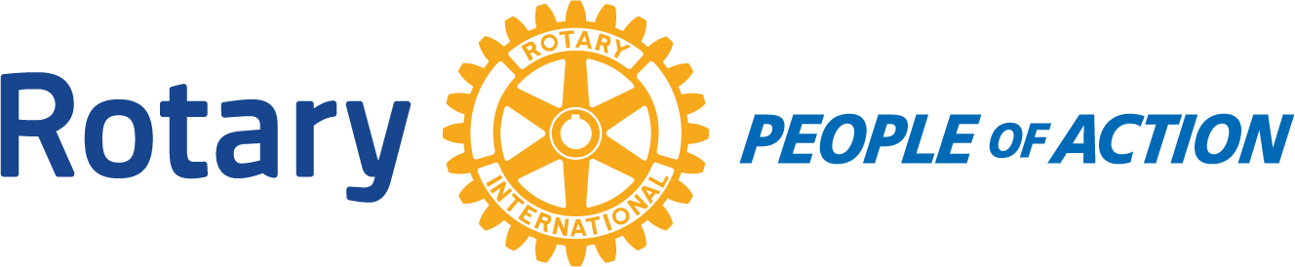

Winslow Rotary Club # 1242 September 16, 2020
Call to order: 12:12pm by President Kevin Coolidge
Pledge of Allegiance
Prayer given by: Greg Hackler
Announcements:
Chipper Cunningham-food distribution next Thursday 9-24-2020. Help is always needed.
Kevin Coolidge-received a request from the City Manager John Barkley to see if any Rotarian would like to be on the Regional Brownsfield Commission.
Guest Speaker: Ken Arend Chief of Police for the Winslow Police Department
Adjournment: 12:58pm
Date/Time of Next regular Meeting: September 23, 2020
Respectfully Submitted By:
Jessica Cox-Atha, Club Secretary

