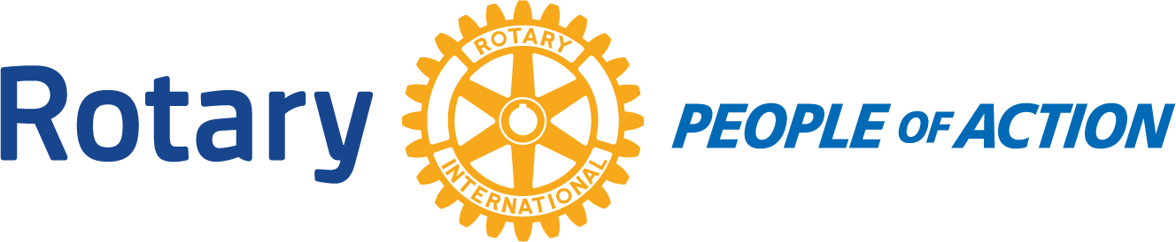

Winslow Rotary Club # 1242 July 15, 2020
Call to order: 12:13m by President Kevin Coolidge
Pledge of Allegiance
Prayer given by:
Announcements:
July 22, 2020 is a Board Meeting.
Meeting:
This meeting was scheduled to be a “Fun” meeting. Presenter was unable to attend. Members present just chatted and enjoyed lunch.
Adjournment: 12:57pm
Date/Time of Next Meeting: July 29, 2020

Respectfully Submitted By:
Jessica Cox-Atha, Club Secretary

