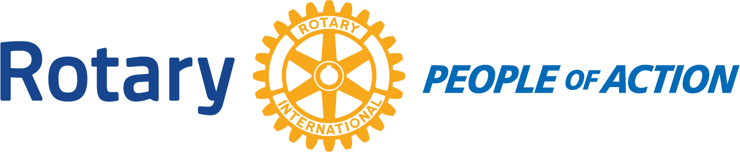

Winslow Rotary Club # 1242 September 9, 2020
Call to order: 12:14pm by President Kevin Coolidge
Pledge of Allegiance
Prayer given by: Dave Heartman
Announcements:
Program: Dave Heartman about cattle.
Adjournment: 12:59pm
Date/Time of Next regular Meeting: September 16, 2020
Respectfully Submitted By:
Jessica Cox-Atha, Club Secretary

