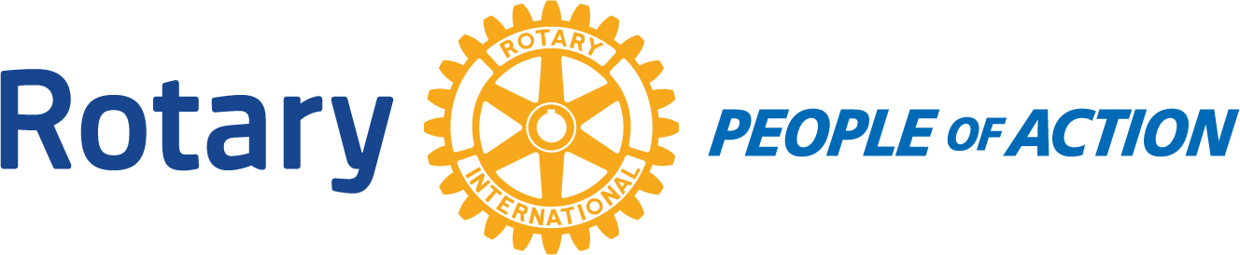

Winslow Rotary Club # 1242 July 8, 2020
Call to order: 12:07pm by President Kevin Coolidge
Pledge of Allegiance
Prayer given by: Greg Hackler
Announcements:
Greg Hackler: Standing On The Corner is officially canceled this year. SOC posted to Facebook to announce. As an additional revenue stream item they have a new vendor for bricks for the corner that are for sale. In October John Pugh will be working on the Standing On The Corner mural.
Special presentation: Greg Hackler presented Kevin Coolidge with a Rotarian of the Year plaque.
Guest Speaker: Barb Hawkins, Infection Preventionist from LCMC gave a COVID-19 update and dispelled any misconceptions or rumors.
Next weeks meeting is a “Fun Meeting” Greg Hackler has something entertaining planned.
Adjournment: 12:47pm
Date/Time of Next Meeting: July 15, 2020
Respectfully Submitted By:
Jessica Cox-Atha, Club Secretary

