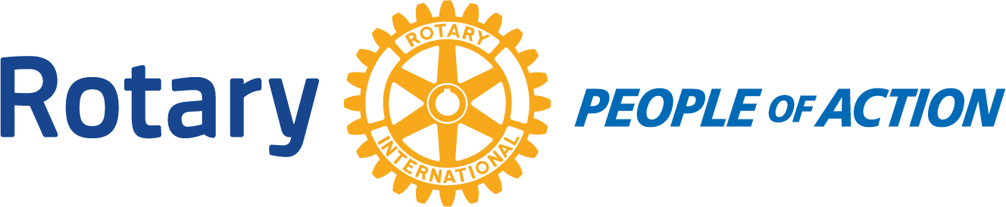

BOARD MEETING
Winslow Rotary Club # 1242 July 22, 2020
Call to order: 12:13pm by President Kevin Coolidge
Pledge of Allegiance
Prayer given by: Harold Soehner
Board Members Present:
Kevin Coolidge Kristy Armijo Jessica Cox-Atha
Board Members Absent:
Jimmy Atha Greg Hackler Chipper Cunningham
Rotarians Present at meeting:
Harold Soehner Elias Jouen Stephanie Lugo
*Increasing dues to Rotary Foundation: Reasoning that the Club will be eligible for grants. (Could cover the cost of our scholarships). Item tabled until next Board Meeting.
*Board duties: Open discussions with other members present.
*4 Way Test: Discussion arose about member actions toward each other and while in public. Good idea to start to recite the 4 Way Test at least one meeting per month.
Adjournment: 1:01pm
No meeting=July 29, 2020
Date/Time of Next Meeting: August 5, 2020

Respectfully Submitted By:
Jessica Cox-Atha, Club Secretary

