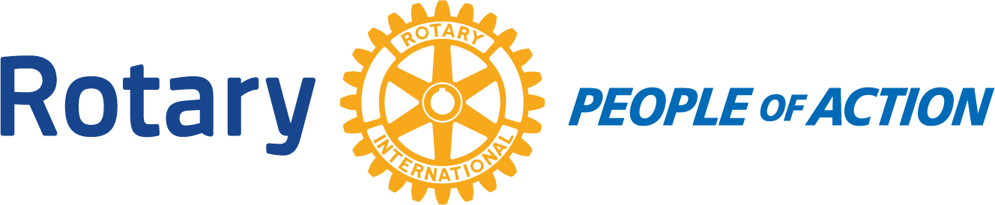

Winslow Rotary Club # 1242 September 2, 2020
Call to order: 12:14pm by President Kevin Coolidge
Pledge of Allegiance
Prayer given by: Greg Hackler
Announcements:
Stephanie raffled off 2 bags. The proceeds went to the Scholarship program. She raised $200.
Chipper Cunningham: Talked about the backpack program. He decided to hold off until the children are back to school in person to start back up.
The Club decided to send $500 to Rotary International.
Greg Hackler is the Membership Chair and he announced his committee members; Stephanie Lugo and Harold Soehner.
Kevin handed out a survey and requested that they be returned at the next meeting.
Adjournment: 12:57pm
Date/Time of Next regular Meeting: September 9, 2020
Respectfully Submitted By:
Jessica Cox-Atha, Club Secretary

